Name:  Class: | ____________________________________  ________________ |  | Date:_________
 | Year 11 Essential Mathematics 2018  / 13  Weighting: 1%  Mini-Test 1.6  Topic – Units of Energy – Practical Applications
Total Time: | 15 minutes
Weighting: | 1%
Equipment: | To be provided by the student: Pen, pencil, ruler,1 single sided A4 page of notes, scientific calculator

Full working out must be shown to get full marks. Attempt all questions.

Question 1 4 marks

Convert the following:
- 5 kW to W b) 2670 W to kW c) 589 W to kW d) 4.23 kW to W

Question 2 3 marks

Find the energy used by:
- 850 W washing machine used for 2 hours

- 100 W laptop used for 4 hours, 30 minutes

- 350 W electric blanket used for 45 minutes

Question 3 4 marks

While preparing breakfast, Terry used a 1520 W toaster for 12 minutes, a 2200 W kettle for 6 minutes, and a 300 W blender for 3 minutes.
- Which appliance used the most energy? Support your answer with reasoning.

Question 4 5 marks

- Fill in the missing information on this power bill.

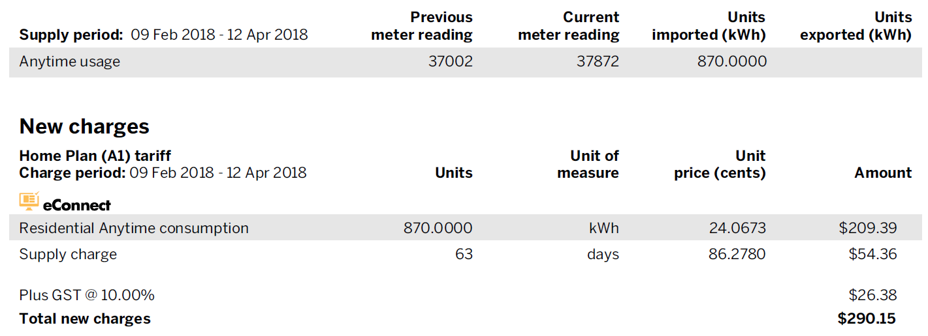

- What is the average daily use of energy during the billing period?

